Motion detection using pir sensor

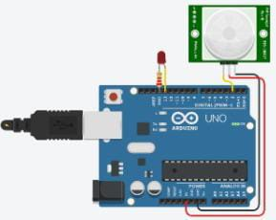

C code for Motion detection using pir sensor:

int buttonState = 0;

void setup()

{

pinMode(2, INPUT);

pinMode(LED_BUILTIN, OUTPUT);

}

void loop()

{

// read the state of the pushbutton

buttonState = digitalRead(2);

// check if pushbutton is pressed. if it is, the

// button state is HIGH

if (buttonState == HIGH) {

digitalWrite(LED_BUILTIN, HIGH);

} else {

digitalWrite(LED_BUILTIN, LOW);

}

delay(10); // Delay a little bit to improve simulation performance

}

**Link**

https://www.tinkercad.com/things/bcqJ0opnxl1-copy-of-pir-motion-sensor/editel?sharecode=szD0yekXG0NGsVgTS51aXRbUZ74YC9EGeepXU6HqrwU